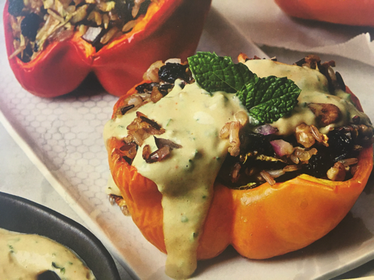
Stuffed bell peppers with herby cashew sauce

This recipe has an especially tasty sauce. This is a very useful accompaniment to many other meals too, including a barbecue. Delicious and nutritious!

Serves: 4

Ingredients:

For the filling:
175g (6oz) uncooked wild rice (or other rice)
1 small courgette, grated
125g (4 ½ oz) raw walnuts, roughly chopped
¼ of a red onion, finely chopped
75g (2 ¾ oz) currants
3 tbsp extra-virgin olive oil
¾ tsp sea salt
Freshly ground black pepper, to taste
2 large red bell peppers, cut in half and seeds removed
2 large orange bell peppers, cut in half and seeds removed

For the sauce:
60g (2oz) cashew butter (instead of cashew butter, unsalted cashew nuts can be boiled for 10 minutes to soften)
60ml (2fl oz) freshly squeezed lemon juice (about 2 lemons)
2 tbsp tahini
1 garlic clove, finely chopped
1 tbsp nutritional yeast (available at most supermarkets)
1 tbsp roughly chopped parsley
1 tbsp roughly chopped fresh mint
½ tsp sea salt
Freshly ground black pepper, to taste
1 small cucumber, finely chopped

Instructions:

- For the filling, preheat the oven to 190°C/Gas Mark 5.
- Line a baking sheet with parchment paper and set aside
- Cook the rice to packet's instructions.
- In a large bowl, combine the cooked rice, courgette, walnuts, onions, currants, oil, salt and pepper.
- Stuff the bell peppers with the wild rice mixture and place on the lined baking sheet. Bake for 45 minutes.
- For the sauce, in a blender combine the cashew butter (or softened cashews), lemon juice, 60ml (2fl oz) water, tahini, garlic, nutritional yeast, parsley, mint, salt and pepper. Blend until smooth. Add extra water for the consistency required. Stir in the cucumber. Serve the stuffed peppers with the cucumber sauce on the side.

Recipe and photo adapted from ‘Ageless Vegan’ by Tracye McQuirter with Mary McQuirter, published by Da Capo Lifelong Books.

