Nutty Mushroom Sausages

By MaryAnne Hall for Viva’s Vegan Recipe club (www.veganrecipeclub.org.uk)
Makes 8 sausages

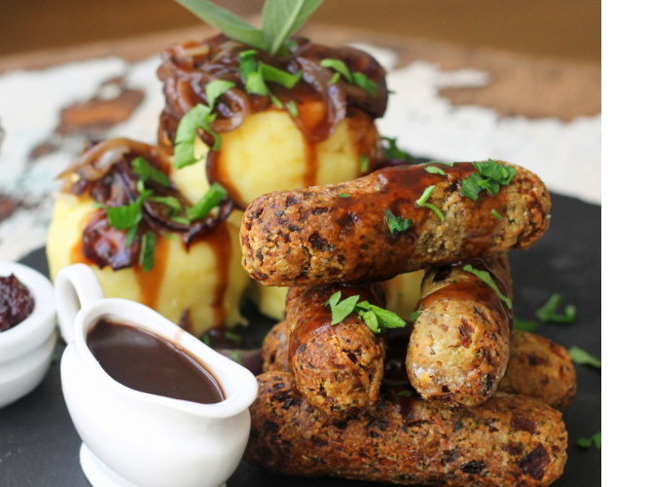

These are lovely, and a great alternative to the shop-bought variety. Eat them for breakfast, lunch or dinner!
They can be made the day before and refrigerated to save time.
They freeze well so it's worth making a couple of batches.
They are baked, so lower in fat than shop-bought versions.
There is a gluten and soya-free option if so desired.

Ingredients:
- 2 tsp olive oil
- 1 medium onion, red or white, peeled and grated
- 1-2 garlic cloves, crushed
- 110g/4oz mushrooms, finely chopped
- 60g/2oz cashews or other nut of choice (or a mixture), ground medium fine
- 60g/2oz fresh wholemeal breadcrumbs - use GF alternative OR certified GF porridge oats instead if desired
- 60g/2oz wholemeal flour plus a little extra for coating OR GF flour
- 2 tsp sieved gram flour (also called besan or chickpea flour) OR soya flour, mixed to a smooth paste with 1 tsp water
- 1 tbsp flax meal (ground linseeds), mixed with 3 tbsp hot water
- 1 tbsp chopped fresh parsley OR 1 tsp dried
- 1-2 tsp chopped fresh tarragon OR ½ tsp dried
- 1 tbsp dairy-free milk, unsweetened if possible - eg rice, coconut, almond, soya, hemp etc
- Salt and lots of fresh black pepper
- Plain oil for baking OR low-cal oil spray

Notes…
Can omit adding 2 tsp sieved gram flour or soya flour and water if mixture binds together without it.
Suggest the addition of approx. 1 teaspoon of Marmite dissolved in a little hot water to taste.

Method:
1. Heat the 2 tsp olive oil in a saucepan and fry the onion until it starts to soften. Add the garlic and cook in for a minute or two. Add the mushrooms and fry for 1-2 minutes then remove from heat.
2. Add the nuts, breadcrumbs, flour, gram/soya flour mix, flax meal mix plus the herbs. Mix well. Then add the milk, salt and pepper to taste. Stir until the mixture binds and then divide it into eight sausages. Dust with a light coating of flour then refrigerate for 30+ minutes or overnight if possible.
3. Pre-heat the oven to 180°C/350°F/Gas Mark 4.
4. Brush a non-stick baking tray and the sausages with a little oil or oil spray.
5. Bake for 15-20 minutes, turning once.

