Risborough Area Community Bus

We’re back!!

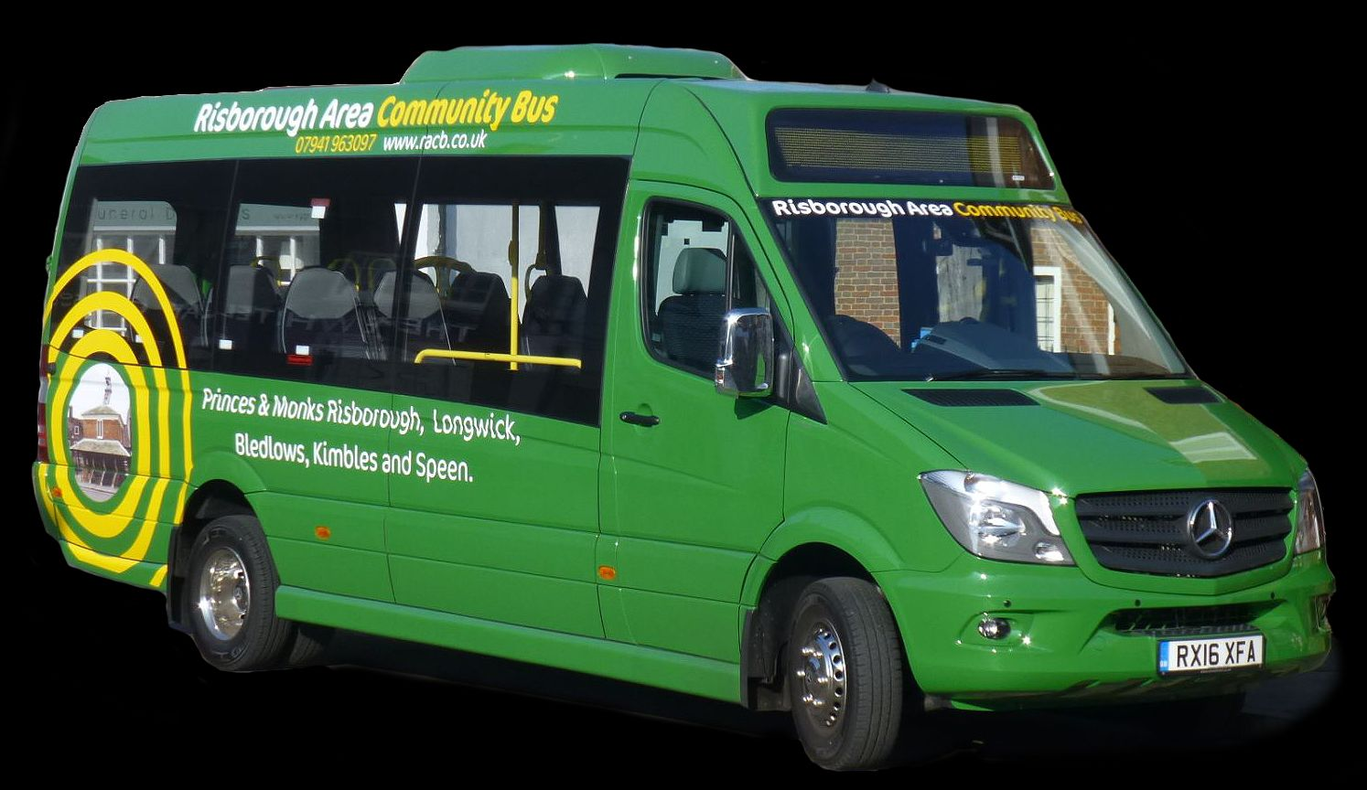

Many of you will have seen the flyers and timetable come through your door to advertise restarting our Risborough Area Community Bus service. We will be coming to Speen every Tuesday from 27 July. We route from Risborough up the Hampden Road arriving around 9am, then round Studridge Lane back to the KW4 and then back to Risborough. Just wave and we will stop and pick you up. To return we leave the George & Dragon in the High Street at 1135 arriving back in Speen by midday. By request, we can put on an afternoon run leaving the G&D at 1605. If you have a bus pass or under 16 the service is free, otherwise just £2. Two of our volunteer drivers are Speen locals and both are looking forward to providing a great service again, the service having been shut down since last March. Do come and ride with us.

For more information, see www.racb.co.uk or call our Coordinator on 07941 963097

